AUTOMATED PAINTING ROVER (APR)
Work Breakdown Structure
Use-Case Document

1. Task Objective
Select a single target application for the Automated Painting Rover (APR), define the environment conditions, surface types, access constraints, and establish clear success criteria for the chosen use-case.
Target Applications — Decision:
Target Application | Decision
Wall painting — exterior vertical surfaces of buildings | SELECTED
Steel tank painting — large industrial cylindrical tanks | Not selected (future scope)
Inclined surface painting — sloped roofs or embankments | Not selected (future scope)
Bridge infrastructure painting — horizontal and vertical beams | Not selected (future scope)

Justification: The DPR submitted for the MSME grant (Ref. INC25ETS084848, approved by the 10th PMAC on 24/03/2026) is written around vertical wall adhesion and building-exterior painting as the primary demonstration case — this selection keeps the prototype consistent with the funded proposal. Wall painting also represents the largest addressable market segment identified in the DPR's market analysis (high-rise and commercial building exteriors) and carries the lowest technical risk for a first working prototype, since it avoids the added complexity of overhead/underside painting (bridges) or convex curved-surface adhesion (tanks). Tank, inclined-surface and bridge painting remain documented as Phase-2 expansion targets once the core adhesion and navigation stack is validated.

2. Environment Conditions & Surface Types
Parameter | Options | APR Consideration — Decision
Surface Type | Concrete, steel, brick, plaster | Concrete and plaster exterior wall finishes (majority of Indian residential/commercial building stock). Adhesion module tuned for moderately porous, textured surfaces.
Orientation | Vertical, inclined, overhead | Vertical (primary use-case). Vacuum pump sized to sustain grip plus payload (rover + paint reservoir + arm) with a safety margin on smooth-to-medium-textured vertical walls.
Environment | Indoor / Outdoor / Hazardous | Outdoor. Enclosure rated to withstand sun, light rain and dust (target IP54) since exterior building painting is weather-exposed.
Access Constraints | Scaffolding-free, confined spaces | Scaffolding-free operation is the core value proposition — rover must self-climb the wall face without external rigging.
Paint Type | Water-based, oil-based, epoxy | Water-based exterior emulsion as the primary paint type; nozzle/pump validated for oil-based paints as a secondary option.

3. Success Criteria
- Rover adheres and moves on the target surface without slipping or falling
- Uniform paint coat achieved across 90% of the designated surface area
- No manual intervention required during the painting operation
- Paint thickness deviation within ±0.5 mm from the specified value
- Operation completed within the estimated time per unit area
- Zero human exposure to toxic paint fumes or hazardous height conditions
- IoT monitoring dashboard active throughout the operation

4. Team Brainstorming Notes
The team (Sai Srujana, Jitesh Kumar, More Gopi) held structured brainstorming sessions on 5th–8th June 2026 under the guidance of Dr. G. L. Anand Babu to evaluate spray mechanism, adhesion and locomotion options. Conclusions:
- Suction/vacuum adhesion vs. magnetic adhesion: Vacuum adhesion selected — the target surfaces (concrete, plaster) are non-ferrous, so magnetic adhesion is not viable; vacuum suction works across all four candidate surface types and keeps the door open for the Phase-2 steel-tank use-case.
- Track-based vs. wheeled locomotion: Track-based locomotion selected for vertical surfaces — it distributes the rover's weight over a larger contact area, maintaining vacuum seal integrity better than point-contact wheels during motion.
- Airless vs. air-assisted spray nozzles: Airless spray selected for the primary nozzle — lower overspray and more consistent film thickness on vertical surfaces, which directly supports the ±0.5 mm thickness-deviation success criterion.
- Manual override: A physical emergency-stop button on the rover chassis plus a remote kill-switch on the IoT dashboard are mandatory safety features, independent of the autonomous control loop.
- Regulatory & safety compliance: No occupant is present on the wall during operation, eliminating fall-from-height risk; the operator manual will specify ventilation guidance for enclosed/confined applications reserved for later phases.

5. Case Study — Why We Chose to Build APR
This is a real, recent incident from our own region that shaped the team's motivation for this project.
On 30th May 2026, a 50-year-old painter, Parameswar Reddy, was working from a suspended platform (locally called a "jhoola") on the third floor of a five-storey residential apartment block under construction — V Four Homes, HBS Colony, Emmiganur town, Kurnool district, Andhra Pradesh — when the platform suddenly tilted. He fell and died of his injuries at the site. Local police registered a case and an inquiry was opened into whether required safety equipment and construction-labour safety norms had been followed.
This is not an isolated case. News and workplace-safety reports from the US and elsewhere describe the same pattern again and again — painters harnessed to failing scaffolds, unsecured balconies giving way, workers falling tens of feet while simply doing routine exterior wall painting. The common thread in every one of these incidents is the same: a human being suspended at height, on rented or improvised rigging, with no fallback if that rigging fails.
This is precisely the gap APR is built to close — replace the person on the rope with a vacuum-adhered rover on the wall, and move the human operator to the ground, in front of an IoT dashboard, for good.
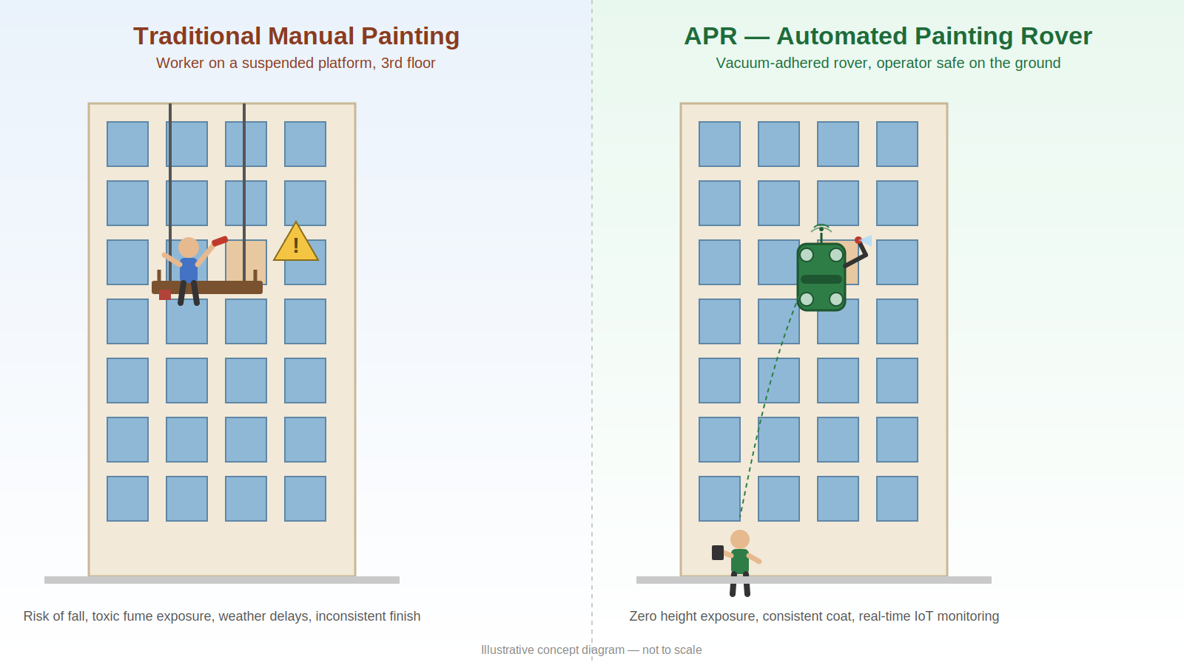
Fig. 1 — Manual suspended-platform painting (left) vs. APR wall-adhered autonomous painting (right)

APR Project | Anurag University | Ref: INC25ETS084848

